**INTRODUCTION**

**MULTIPLE DISEASE PREDICTION SYSTEM**

**1. INTRODUCTION**

In recent years, the integration of machine learning techniques into healthcare systems has revolutionized disease diagnosis and prediction. The advent of sophisticated algorithms and the abundance of healthcare data have paved the way for the development of predictive models capable of foreseeing various medical conditions with remarkable accuracy. In this context, the emergence of multiple disease prediction systems stands as a beacon of hope, offering proactive and personalized healthcare solutions to individuals worldwide.

This paper presents an in-depth exploration of a cutting-edge multiple disease prediction system empowered by machine learning algorithms. By harnessing the power of artificial intelligence, this system aims to revolutionize traditional healthcare paradigms by providing timely and accurate predictions for a diverse range of diseases, spanning from chronic conditions to infectious outbreaks

In summary, the integration of machine learning into multiple disease prediction systems heralds a new era of proactive and personalized healthcare. By harnessing the predictive power of artificial intelligence, these systems have the potential to revolutionize disease diagnosis, prevention, and management, ultimately enhancing the well-being of individuals and communities worldwide.

The Earth is going through a purplish patch of technology where the demand of intelligence and accuracy is increasing behind it. Today's people are likely addicted to internet but they are not concerned about their physical health. People ignore the small problem and don't visit to visit hospital which turn into serious disease with time. Taking the advantage of this growing technology, our basis aim is to develop such a system that will predict the multiple diseases in accordance with symptoms put down by the patients without visiting the hospitals / physicians. Machine Learning is a subset of AI that is mainly deal with the study of algorithms which improve with the use of data and experience. Machine Learning has two phases i.e. Training and Testing. Machine Learning provides an efficient platform in medical field to solve various healthcare issues at a much faster rate. There are two kinds of Machine Learning – Supervised Learning and Unsupervised Learning. In supervised learning we frame a model with the help of data that is well labelled. On the other hand, unsupervised learning model learn from unlabeled data. The intent is to deduce a satisfactory Machine Learning algorithm which is efficient and accurate for the prediction of disease. In this paper, the supervised Machine Learning concept is used for predicting the diseases. The main feature will be Machine Learning in which we will be using machine learning algorithm which will help in early prediction of diseases accurately and better patient care

Top of Form

**1.1 OBJECTIVES**

Multiple disease prediction system using machine learning can contribute to improving healthcare outcomes, enhancing population health management, and advancing preventive medicine and personalized healthcare. To develop a robust and accurate predictive system capable of early detection and diagnosis of multiple diseases based on various input parameters such as symptoms, medical history, demographics, and diagnostic tests. The system aims to improve patient outcomes by providing timely interventions, personalized treatment recommendations, and risk assessments for a range of prevalent diseases, ultimately enhancing healthcare delivery and reducing morbidity and mortality rates.

The smart health prediction system focused for optimally reducing the healthcare costs. There are several functionalities remain untouched into health prediction system. So by living in the edge of technology and still if we are not able to utilize it in efficient and proper manner then there is no use of it. To tackle this, research is carried out in health prediction system. There are several applications which use any one of the technology. This project shows the merging of both technologies to achieve efficient result.

**1.2 ABSTRACT**

In modern healthcare, early diagnosis plays a crucial role in effective treatment and management of diseases. This project presents a multi-disease prediction system leveraging machine learning algorithms for accurate diagnosis. The system is designed to predict the likelihood of various diseases based on input features such as symptoms, demographic data, and medical history.

In this era of technological advancement, the integration of machine learning algorithms into healthcare systems has shown promising results in predicting various diseases. This project presents a Multiple Disease Prediction System utilizing machine learning techniques, specifically designed for predicting three prevalent health conditions: diabetes, heart disease, and Parkinson's disease. The system employs supervised learning algorithms trained on relevant medical datasets to develop accurate prediction models for each disease category. The Flask web framework is utilized for deploying the prediction system, providing a user-friendly interface accessible via web browsers. Users can input relevant health parameters, and the system delivers predictions regarding the likelihood of each disease. Through the integration of machine learning and web development technologies, this system aims to enhance early disease detection, facilitate proactive healthcare management, and ultimately contribute to improved patient outcomes and healthcare delivery.

Top of Form

**1.3 MODULES**

* + - * Data Collection and Preprocessing
      * Feature Selection and Dimensionality Reduction
      * Model Development and Training
      * Deployment and Integration
* **Data Preprocessing Module**

This module is responsible for cleaning and preparing the raw medical data for analysis. It involves tasks such as handling missing values, normalization, feature selection, and data transformation.

* **Feature Extraction**

Extract relevant features from the preprocessed data. This could involve techniques such as principal component analysis (PCA), feature selection algorithms, or domain-specific feature extraction methods.

* **Deployment Module**

Deploy the prediction system in a production environment. Choose an appropriate deployment platform such as cloud services (e.g., AWS, Azure, Google Cloud) or on-premises servers. Implement monitoring and logging mechanisms to track system performance and usage.

* **Machine Learning Models Training Module**

Implement various machine learning algorithms for disease prediction. Common algorithms include logistic regression, decision trees, random forests, support vector machines (SVM), k-nearest neighbors (KNN), and neural networks. Each algorithm can be a separate module within this section.

**SYSTEM ANALYSIS**

**2. SYSTEM ANALYSIS**

**2.1 EXISTING MODEL**

Machine learning models play a crucial role in disease prediction by leveraging patterns and relationships within healthcare data to forecast the likelihood of individuals developing specific diseases.

Overall, machine learning models in disease prediction offer the potential to improve patient outcomes, optimize healthcare resource allocation, and inform preventive and personalized medicine strategies. However, ensuring the accuracy, interpretability, and ethical use of these models remains critical for their successful implementation in clinical practice

**DISADVANTAGES**

* **Data Quality and Bias**: The performance of machine learning models heavily depends on the quality, completeness, and representativeness of the training data. Biases in the data, such as underrepresentation of certain demographic groups or medical conditions, can lead to biased predictions and exacerbate health disparities.
* **Overfitting**: Machine learning models may become overly complex and memorize noise or outliers in the training data, leading to poor generalization performance on unseen data. Overfitting can occur when the model captures random fluctuations rather than underlying patterns, resulting in inaccurate predictions.
* **Interpretability and Explainability**: Many machine learning models, especially deep learning models, are often considered "black-box" models, meaning that their internal workings are not easily interpretable or explainable. Lack of transparency in model decision-making can hinder trust, acceptance, and understanding by healthcare professionals and end-users.
* **Data Privacy and Security**: Healthcare data used for training machine learning models often contain sensitive and personal information about individuals. Maintaining data privacy and security is crucial to prevent unauthorized access, data breaches, and misuse of confidential health information.
* **Model Validation and Evaluation**: Assessing the performance and reliability of machine learning models in disease prediction requires rigorous validation and evaluation procedures. Inadequate validation methods or reliance on biased evaluation metrics can lead to overestimation of model performance and false confidence in predictions.
* **Dynamic and Evolving Nature of Diseases**: Diseases and their associated risk factors are complex and dynamic, often evolving over time. Machine learning models may struggle to adapt to changing disease patterns, new risk factors, or emerging infectious diseases without continuous retraining and updates.
* **Clinical Utility and Integration**: Integrating machine learning models into clinical practice requires seamless integration with existing healthcare systems, workflows, and decision-making processes. Lack of interoperability, user acceptance, and clinician engagement can hinder the adoption and effectiveness of predictive models in real-world settings.
* **Ethical and Regulatory Considerations**: Machine learning models in healthcare raise ethical concerns related to autonomy, transparency, accountability, and fairness. Ensuring ethical and responsible use of predictive models requires adherence to regulatory guidelines, ethical standards, and guidelines for responsible AI development and deployment.

**2.2 PROPOSED MODEL**

In this proposed model, the development of a multiple disease prediction system using Flask, a popular Python Framework for building interactive web applications. Leveraging machine learning techniques and diverse healthcare data sources, the system aims to predict the likelihood of individuals developing various diseases, facilitating early detection, personalized healthcare recommendations, and population health management. The system features a user-friendly interface built with Flask, allowing healthcare professionals and end-users to input relevant patient data, visualize predictive insights, and interpret model predictions in an intuitive and interactive manner. Through continuous refinement and validation, the system demonstrates promising potential in improving disease prevention, diagnosis, and treatment decision-making, contributing to enhanced patient outcomes and healthcare delivery.

**ADVANTAGES**

* **Early Disease Detection**: Machine learning models can analyze diverse healthcare data sources to identify subtle patterns and risk factors associated with various diseases. By detecting diseases at an early stage, healthcare providers can intervene promptly, leading to better treatment outcomes and potentially reducing healthcare costs.
* **Personalized Risk Assessment**: These systems can tailor disease risk assessments to individual patients by incorporating personal health data, genetic information, lifestyle factors, and medical history. Personalized risk assessments enable healthcare providers to offer targeted interventions and preventive measures based on each patient's unique profile, optimizing healthcare resources and improving patient outcomes.
* **Improved Clinical Decision-Making**: By providing healthcare professionals with decision support tools based on predictive analytics, these systems can assist in diagnosing diseases, stratifying patient risk, and recommending appropriate treatment strategies. Enhanced clinical decision-making leads to more informed and effective patient care, ultimately improving healthcare quality and patient satisfaction.
* **Population Health Management**: Machine learning models can analyze population-level healthcare data to identify disease trends, hotspots, and vulnerable populations. By predicting disease outbreaks, monitoring disease prevalence, and identifying high-risk groups, these systems enable public health authorities to implement targeted interventions and allocate resources more effectively, thereby improving population health outcomes.
* **Reduced Healthcare Costs**: Early disease detection, personalized risk assessment, and targeted interventions facilitated by machine learning-based prediction systems can lead to cost savings in healthcare. By preventing costly complications, reducing hospitalizations, and optimizing resource allocation, these systems contribute to more efficient healthcare delivery and reduced healthcare expenditures.
* **Data-Driven Insights**: These systems generate valuable insights from healthcare data that can inform clinical research, healthcare policy-making, and public health initiatives. By analyzing large-scale healthcare datasets, researchers can identify novel disease risk factors, understand disease progression mechanisms, and develop more effective prevention and treatment strategies, ultimately advancing medical knowledge and improving patient care.
* **Continuous Learning and Improvement**: Machine learning-based prediction systems can continuously learn and adapt to evolving healthcare data and disease patterns. By incorporating new data and feedback, these systems can update their predictive models and recommendations, ensuring their relevance and effectiveness in dynamic healthcare environments.
* **Empowerment of Patients**: By providing individuals with personalized risk assessments, health education, and lifestyle recommendations, these systems empower patients to take proactive control of their health. Increased health literacy and engagement enable patients to make informed decisions, adopt healthier behaviors, and prevent or manage chronic diseases effectively, leading to improved overall well-being and quality of life.

**2.3 MODULES DESCRIPTION**

**Data Collection and Preprocessing:**

* + Gather datasets for the target diseases (e.g., diabetes, heart disease, Parkinson's disease) from reputable sources.
  + Clean the data by handling missing values, outliers, and inconsistencies.
  + Perform feature engineering to select relevant features and transform data for model input.

**Model Development:**

Select appropriate machine learning algorithms for each disease prediction task based on the nature of the data and the prediction goals (e.g., classification algorithms for binary outcomes).

* + Split the data into training and testing sets for model evaluation.
  + Train individual models for each disease using the training data, tuning hyperparameters as necessary to optimize performance.
  + Evaluate model performance using appropriate evaluation metrics (e.g., accuracy, precision, recall, F1-score).

**Ensemble Model (Optional):**

* + Optionally, consider building an ensemble model that combines predictions from individual disease models to improve overall prediction accuracy.
  + Ensemble techniques such as majority voting or stacking can be employed to combine predictions from multiple models.

**Flask Integration:**

* + Develop a web application using the Flask framework to serve as the user interface for the prediction system.
  + Design a user-friendly interface where users can input relevant medical data (e.g., age, gender, blood pressure, cholesterol levels).
  + Implement data validation to ensure that user inputs are within acceptable ranges and formats.
  + Integrate the trained machine learning models into the Flask application, allowing users to receive predictions for multiple diseases simultaneously.

**Deployment:**

* + Deploy the Flask application on a web server or a cloud platform such as Heroku, AWS, or Google Cloud Platform.
  + Configure the deployment environment, ensuring that all necessary dependencies are installed and the application runs smoothly.
  + Monitor the deployed application for performance, scalability, and security considerations.

**User Feedback and Iteration:**

* + Gather user feedback to identify areas for improvement and potential enhancements to the prediction system.
  + Iterate on the model and application based on user feedback, incorporating new features, improving performance, and addressing any issues or concerns raised by users.

**DEVELOPMENT ENVIRONMENT**

**3. DEVELOPMENT ENVIRONMENT**

**3.1 HARDWARE ENVIRONMENT**

PROCESSOR : Intel(R) Core(TM) i3-4005U

RAM : 4 GB

SOLID STATE DRIVE : 128 GB

MONITOR : LED MONITOR

MOUSE : STANDARD WINDOWS MOUSE

KEYBOARD : STANDARD WINDOWS KEYBOARD

**3.2 SOFTWARE ENVIRONMENT**

OPERATING SYSTEM : WINDOWS 10

PLATFORM : VISUAL STUDIO CODE

FRONTEND : HTML**,** CSS

BACKEND : PYTHON

**3.3 SOFTWARE SPECIFICATION**

**Cross-Platform Compatibility:** Visual Studio Code is designed to be accessible across different operating systems, including Windows, macOS, and Linux. This cross-platform compatibility ensures that developers can use the same familiar editor environment regardless of the operating system they're working on, promoting consistency and flexibility in their development workflows.

**Intuitive User Interface:** With its clean and user-friendly interface, Visual Studio Code provides a streamlined environment for coding. The minimalistic design reduces distractions, allowing developers to focus on writing code efficiently. The intuitive layout and navigation features make it easy to find and access essential tools and functionalities within the editor.

**Code Editing:** Visual Studio Code offers a comprehensive set of code editing capabilities to enhance developer productivity. These include features such as syntax highlighting, which helps developers easily identify different elements of their code, auto-completion, which suggests code snippets and completions as developers type, and code snippets, which enable quick insertion of commonly used code patterns, reducing the need for repetitive typing and minimizing coding errors.

**Integrated Terminal:** One of the standout features of Visual Studio Code is its integrated terminal, which allows developers to execute commands, compile code, and run scripts directly within the editor environment. This eliminates the need to switch between the editor and external terminal applications, streamlining development workflows and improving productivity.

**Version Control Integration:** Visual Studio Code seamlessly integrates with version control systems such as Git, providing developers with powerful features for managing code changes and collaborating with team members. With built-in Git support, developers can view file changes, stage and commit changes, and push/pull from remote repositories directly within the editor, facilitating efficient version control workflows.

**Extensibility:** One of the key strengths of Visual Studio Code is its extensibility. The editor supports a vast ecosystem of extensions that extend its functionality for various programming languages, frameworks, and development tools. Developers can customize their coding experience by installing extensions for syntax highlighting, code linting, debugging, and more, tailoring the editor to their specific needs and preferences.

**Debugging:** Visual Studio Code includes built-in debugging support for multiple programming languages, enabling developers to identify and fix issues in their code effectively. With features such as breakpoints, variable inspection, and step-through debugging, developers can analyze the behavior of their code and pinpoint the root causes of errors, streamlining the debugging process and improving code quality.

**Task Automation:** Visual Studio Code allows developers to automate repetitive tasks and workflows using tasks and build configurations. Tasks can be configured to perform various actions such as compiling code, running tests, or executing custom scripts, helping developers streamline their development processes and save time on manual tasks. By defining tasks once and executing them with a single command, developers can improve efficiency and focus more on writing code.

**Coding in Python :** With your project folder open in VS Code, you'll primarily be working on your Python files. These files contain the backend logic for your machine learning models, including model definition ,model training and prediction . You'll write and edit Python code directly within VS Code's code editor.

**Creating Flask web app:** In addition to Python files, you'll also create flask web app for the your application. These files define the structure, styling, and interactivity of your web pages. You can create new files within VS Code and edit them using the built-in code editor.

**Managing Files and Folders:** VS Code's sidebar file explorer allows you to navigate and manage files and folders within your project. You can create, rename, move, and delete files directly from the sidebar, providing a convenient way to organize your project structure.

**Running and Debugging:** As you write code, you'll frequently run and debug your application to test its functionality. VS Code provides an integrated terminal for running commands and executing scripts. You can run your Flask application by executing the appropriate commands in the terminal and debug any issues using VS Code's built-in debugging tools.

**3.4 FRONTEND FRAMEWORK**

**HTML (HyperText Markup Language):** HTML is the standard markup language used to create the structure and content of web pages. In the context of your project, HTML files define the layout and elements of the user interface (UI) that users interact with. Here's the process of working with HTML files:

* **Structure Definition**: HTML files begin with the <html> tag, which encapsulates the entire document. Within this tag, you'll define the structure of your web page using elements like <head>, <body>, and various other HTML tags such as <div>, <input>, <button>, etc.
* **Content Placement**: Within the <body> tag, you'll place content elements like text, images, forms, buttons, and other interactive elements. These elements define the visual and interactive components of your web page.

**CSS (Cascading Style Sheets):** CSS is used to style the visual presentation of HTML elements on a web page. It defines the appearance, layout, and design of the UI elements defined in HTML. Here's the process of working with CSS files:

* **Selectors and Rules**: CSS files contain selectors and rules that target HTML elements and define their visual properties such as color, font, size, margin, padding, and positioning.
* **Styling Elements**: You'll use CSS selectors to target specific HTML elements and apply styles to them. Styles can be applied directly to HTML elements, classes, or IDs, allowing for precise control over the appearance of UI elements.

**3.5 BACKEND FRAMEWORK**

**Flask (Python):** Flask is a micro web framework for Python used to build web applications. In the context of your project, Flask serves as the backend framework responsible for handling server-side logic and interactions with the client. Here's the process of working with Flask:

* **Route Definition**: In Flask, routes are defined using decorators to map URLs to specific functions, known as view functions. These functions handle HTTP requests from the client and return appropriate responses.
* **Request Handling**: Within view functions, Flask provides access to request objects, allowing you to retrieve data sent by the client, such as form data or uploaded files. You can process this data and perform necessary operations based on the client's request.
* **Response Generation**: Flask allows you to generate HTTP responses dynamically using functions like render_template for rendering HTML templates and jsonify for returning JSON responses. These responses are sent back to the client to display the requested content or perform actions.
* **Integration with Libraries**: Flask seamlessly integrates with other Python libraries, allowing you to leverage their functionalities in your web application. This includes libraries for tasks such as image processing, text extraction, database interaction, etc.

**SYSTEM DESIGN**

**4. SYSTEM DESIGN**

**4.1 DATA FLOW DIAGRAM**

Top of Form

Training Data

Bottom of Form

Feature Selection

Building a model

prediction

Test Data

4.2 ARCHITECTURE DIAGRAM

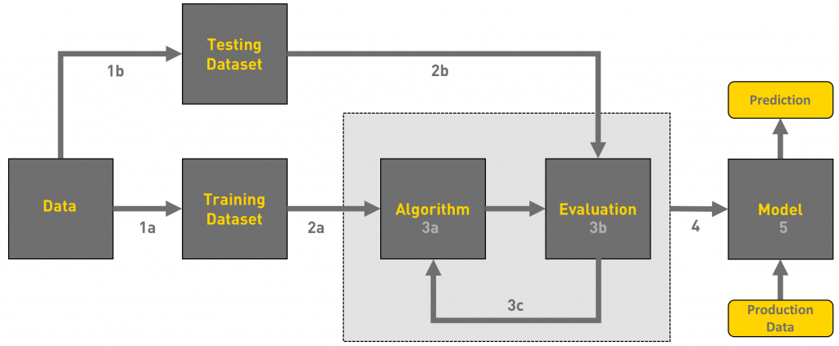

**4.3 ER DIAGRAM**

DATA

PREPROCESSING

INPUT

DATA

DATA

MODEL

BUILDING

DATA CURATION

VALIDATION OF

THE MODEL

**DATASETS AND MODEL**

**5. DATASETS**

**5.1 DIABETES DISEASE DATASET**

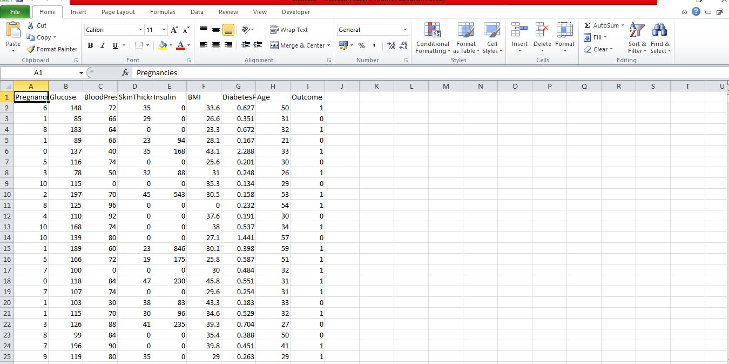

* The diabetes dataset consists of 768 data points, with each datapoint having 8 features. This dataset is Pima Indians Diabetes Database found on the kaggle.

**Features**

* Pregnancies: Number of times pregnant
* Glucose: Plasma glucose concentration a 2 hours in an oral glucose tolerance test
* BloodPressure: Diastolic blood pressure (mm Hg)
* SkinThickness: Triceps skin fold thickness (mm)
* Insulin: 2-Hour serum insulin (mu U/ml)
* BMI: Body mass index (weight in kg/(height in m)^2)
* DiabetesPedigreeFunction: Diabetes pedigree function
* Age: Age (years)

**5.2 HEART DISEASE DATASET**

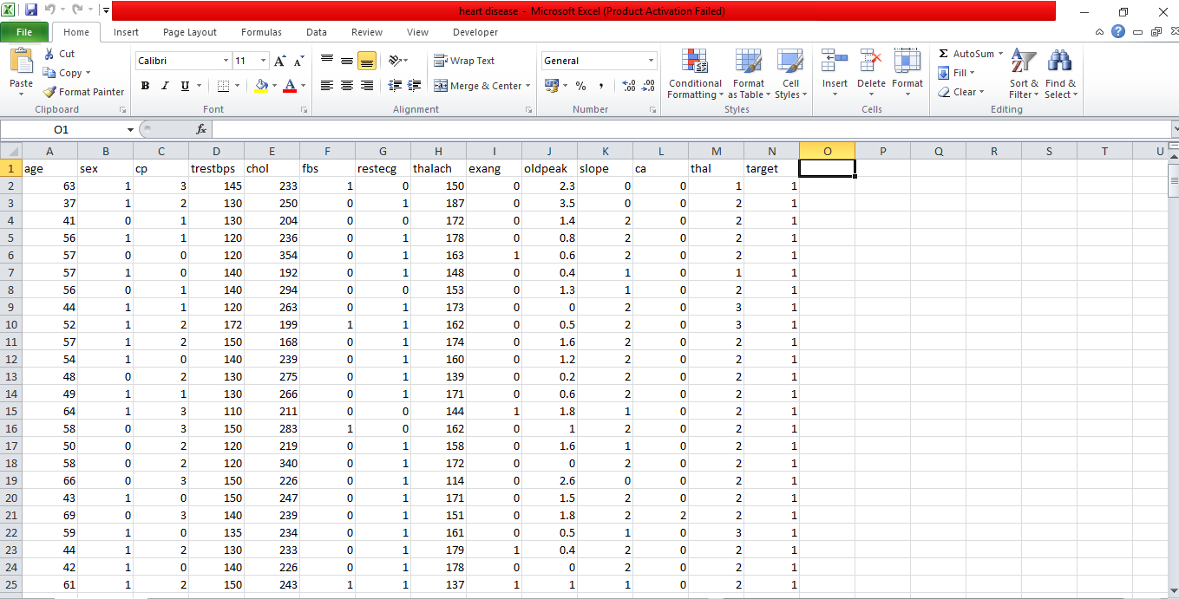

* The heart dataset consists of 1025 data points, with each datapoint having 13 features. This dataset is Heart Disease Dataset found on the kaggle.

**Features**

* age: age in years
* sex: (1 = male; 0 = female)
* cp: chest pain type
* trestbps: resting blood pressure (in mm Hg on admission to the hospital)
* chol: serum cholestoral in mg/dl
* fbs: (fasting blood sugar > 120 mg/dl) (1 = true; 0 = false)
* restecg: resting electrocardiographic results
* thalach: maximum heart rate achieved
* exang: exercise induced angina (1 = yes; 0 = no)
* oldpeak: ST depression induced by exercise relative to rest
* slope: the slope of the peak exercise ST segment
* ca: number of major vessels (0-3) colored by flourosopy
* thal: 0 = normal; 1 = fixed defect; 2 = reversable defect

**Target Variable** 14. target: Class variable (0 or 1) 526 of 1025 are 1, the others are 0. Value 0 = no heart disease and 1 = heart disease

**5.3 PARKINSON’S DISEASE DATASET**

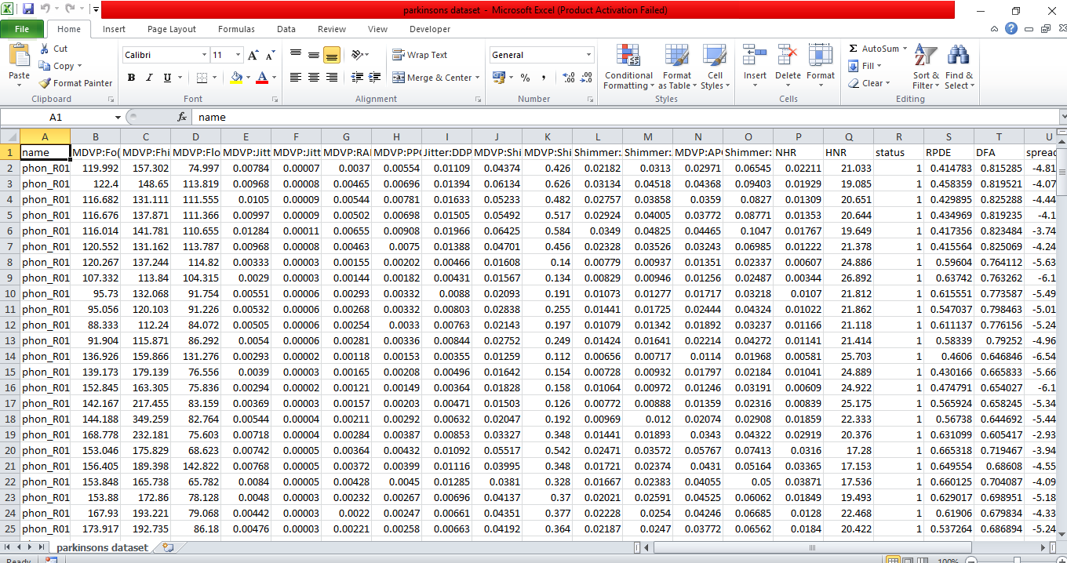

* The ParkinsonsDisease dataset consists of 195 data points, with each datapoint having 22 features. This dataset is Parkinsons Disease Dataset found on the kaggle.

**Features**

* MDVP:Fo(Hz): Average vocal fundamental frequency
* MDVP:Fhi(Hz): Maximum vocal fundamental frequency
* MDVP:Flo(Hz): Minimum vocal fundamental frequency
* MDVP:Jitter(%)
* MDVP:Jitter(Abs)
* MDVP:RAP
* MDVP:PPQ
* Jitter:DDP: Several measures of variation in fundamental frequency
* MDVP:Shimmer
* MDVP:Shimmer(dB)
* Shimmer:APQ3
* Shimmer:APQ5
* MDVP:APQ
* Shimmer:DDA :Several measures of variation in amplitude
* NHR
* HNR: Two measures of ratio of noise to tonal components in the voice
* RPDE
* DFA: Signal fractal scaling exponent
* spread1
* spread2
* PPE: Three nonlinear measures of fundamental frequency variation
* D2: Two nonlinear dynamical complexity measures

**Target Variable** 23. status: Class variable (0 or 1) 147 of 195 are 1, the others are 0. Value 1 - Parkinson's, 0 – healthy

**5.4 SUPPORT VECTOR MACHINE ALGORITHM**

Support Vector Machine or SVM is one of the most popular Supervised Learning algorithms, which is used for Classification as well as Regression problems. However, primarily, it is used for Classification problems in Machine Learning.

The goal of the SVM algorithm is to create the best line or decision boundary that can segregate n-dimensional space into classes so that we can easily put the new data point in the correct category in the future. This best decision boundary is called a hyperplane.

SVM chooses the extreme points/vectors that help in creating the hyperplane. These extreme cases are called as support vectors, and hence algorithm is termed as Support Vector Machine. Consider the below diagram in which there are two different categories that are classified using a decision boundary or hyperplane:

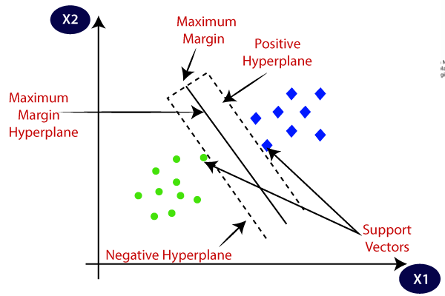

SVM algorithm can be used for Face detection, image classification, text categorization, etc.

**Working of SVM algorithm:**

SVM works by mapping data to a high-dimensional feature space so that data points can be categorized, even when the data are not otherwise linearly separable. A separator between the categories is found, then the data are transformed in such a way that the separator could be drawn as a hyperplane. Following this, characteristics of new data can be used to predict the group to which a new record should belong.

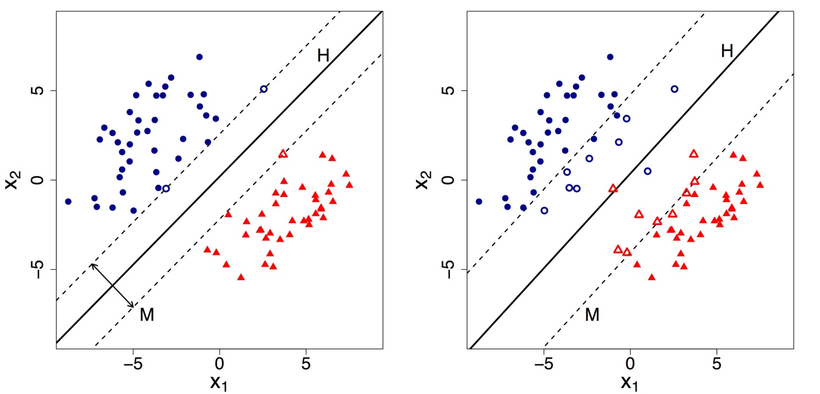

**Advantages:**

Here are some of the key benefits:

* **Effective in High-Dimensional Spaces:**

- SVMs can handle high-dimensional data efficiently, making them suitable for complex datasets with many features.

* **Robust to Overfitting:**

- SVMs aim to find the optimal separating hyperplane with the largest margin between classes, reducing the risk of overfitting. This makes SVMs robust, especially when the data contains noise.

* **Effective with Non-linear Boundaries:**

- Using kernel functions (like polynomial, radial basis function, etc.), SVMs can handle non-linear decision boundaries, making them flexible for complex data patterns.

* **Well-Defined Solution:**

- Given that SVMs aim to maximize the margin, they typically find a unique solution, resulting in a stable and deterministic model.

* **Versatility:**

- SVMs can be used for both classification and regression tasks, providing a wide range of applications.

- They can also handle multi-class classification through techniques like one-vs-rest or one-vs-one.

**5.5 LOGISTIC REGRESSION ALGORITHM**

Logistic regression is a statistical method used for predicting the probability of a binary outcome based on one or more predictor variables. It's widely used in various fields such as machine learning, statistics, and epidemiology for classification tasks.

Here's how logistic regression works:

* **Binary Outcome:** Logistic regression is used when the dependent variable (the outcome you're predicting) is binary, meaning it has only two possible outcomes. For example, it could be "yes" or "no," "0" or "1," "success" or "failure," etc.
* **Linear Combination:** Logistic regression models the relationship between the predictor variables and the log-odds of the outcome. The log-odds (also called the logit function) is the natural logarithm of the odds of the event happening (the probability of success divided by the probability of failure).
* **Sigmoid Function:** The linear combination of predictor variables is transformed using a sigmoid function (also known as the logistic function). The sigmoid function maps any real-valued number to a value between 0 and 1. This transformed value represents the probability of the outcome variable being in the positive class.
* **Model Training:** During the training phase, the logistic regression algorithm estimates the parameters (coefficients) of the model that best fit the data. This is typically done using optimization techniques such as maximum likelihood estimation.
* **Decision Boundary:** Once the model is trained, it can be used to make predictions on new data. The decision boundary is the threshold value (usually 0.5) that separates the two classes. If the predicted probability is greater than the threshold, the observation is classified as belonging to the positive class; otherwise, it's classified as belonging to the negative class.
* **Evaluation:** The performance of a logistic regression model can be evaluated using various metrics such as accuracy, precision, recall, F1-score, ROC curve, and AUC-ROC (Area Under the ROC Curve).

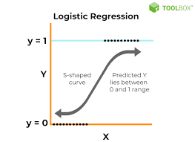

In summary, logistic regression models the probability of a binary outcome using a linear combination of predictor variables, transformed by a sigmoid function. It's a powerful and interpretable tool for binary classification tasks.

Top of Form

**SYSTEM** **IMPLEMENTATION**

**6. SYSTEM IMPLEMENTATION**

**6.1 BACKEND CODING**

from flask import Flask, render_template, request, jsonify

import pickle

import numpy as np

app=Flask(__name__)

# instantiate object

#loading the different saved model for different disease

diabetes_predict=pickle.load(open('diabetes.pkl', 'rb'))

heart_predict=pickle.load(open('heart.pkl', 'rb'))

parkinsons_predict=pickle.load(open('parkinsons.pkl', 'rb'))

@app.route('/') # instancing one page (homepage)

def home():

return render_template("home.html")

# ^^ open home.html, then see that it extends layout.

# render home page.

@app.route('/diabetes') # instancing child page

def diabetes():

return render_template("diabetes.html")

@app.route('/parkinsons/') # instancing child page

def parkinsons():

return render_template("parkinsons.html")

@app.route('/heartdisease/') # instancing child page

def heartdisease():

return render_template("heartdisease.html")

@app.route('/predictdiabetes/',methods=['POST'])

def predictdiabetes(): #function to predict diabetes

int_features=[x for x in request.form.values()]

processed_feature_diabetes=[np.array(int_features,dtype=float)]

prediction=diabetes_predict.predict(processed_feature_diabetes)

if prediction[0]==1:

display_text="This person has Diabetes"

else:

display_text="This person doesn't have Diabetes"

return render_template('diabetes.html',output_text="Result: {}".format(display_text))

@app.route('/predictparkinson/',methods=['POST'])

def predictparkinsons(): #function to predict parkinsons disease

int_features=[x for x in request.form.values()]

processed_feature_parkinsons=[np.array(int_features,dtype=float)]

prediction=parkinsons_predict.predict(processed_feature_parkinsons)

if prediction[0]==1:

display_text="This person has Parkinson's"

else:

display_text="This person doesn't have Parkinson's"

return render_template('parkinsons.html',output_text="Result: {}".format(display_text))

@app.route('/predictheartdisease/',methods=['POST'])

def predictheartdisease(): #function to predict heart disease

int_features=[x for x in request.form.values()]

processed_feature_heart=[np.array(int_features,dtype=float)]

prediction=heart_predict.predict(processed_feature_heart)

if prediction[0]==1:

display_text="This person has Heart Disease"

else:

display_text="This person doesn't have Heart Disease"

return render_template('heartdisease.html',output_text="Result: {}".format(display_text))

if __name__=="__main__":

app.run(debug=True)

**6.2 FRONTEND CODING**

**#diabetes.html**

{%extends "layout.html"%}

{%block content%}

<style type="text/css">

.form-style-3{

max-width: 900px;

font-family: "Lucida Sans Unicode", "Lucida Grande", sans-serif;

padding: 20px;

}

.form-style-3 label{

display:block;

margin-bottom: 10px;

}

.form-style-3 label > span{

float: left;

width: 350px;

color: #fff;

font-weight: bold;

font-size: 18px;

text-shadow: 1px 1px 1px #fff;

}

.form-style-3 fieldset{

border-radius: 10px;

-webkit-border-radius: 10px;

-moz-border-radius: 10px;

margin: 0px 0px 10px 0px;

border: 1px solid #f5ac1b;

padding: 20px;

background: #db74af;

box-shadow: inset 0px 0px 15px #FFE5E5;

-moz-box-shadow: inset 0px 0px 15px #FFE5E5;

-webkit-box-shadow: inset 0px 0px 15px #FFE5E5;

}

.form-style-3 fieldset legend{

color: #f21bb2;

border-top: 1px solid #FFD2D2;

border-left: 1px solid #FFD2D2;

border-right: 1px solid #FFD2D2;

border-radius: 5px 5px 0px 0px;

-webkit-border-radius: 5px 5px 0px 0px;

-moz-border-radius: 5px 5px 0px 0px;

background: #FFF4F4;

padding: 0px 8px 3px 8px;

box-shadow: -0px -1px 2px #F1F1F1;

-moz-box-shadow:-0px -1px 2px #F1F1F1;

-webkit-box-shadow:-0px -1px 2px #F1F1F1;

font-weight: normal;

font-size: 25px;

}

.form-style-3 textarea{

width:250px;

height:100px;

}

.form-style-3 input[type=text],

.form-style-3 input[type=number],

.form-style-3 select,

.form-style-3 textarea{

border-radius: 3px;

-webkit-border-radius: 3px;

-moz-border-radius: 3px;

border: 1px solid #FFC2DC;

outline: none;

color: #121211;

padding: 5px 8px 5px 8px;

box-shadow: inset 1px 1px 4px #FFD5E7;

-moz-box-shadow: inset 1px 1px 4px #FFD5E7;

-webkit-box-shadow: inset 1px 1px 4px #FFD5E7;

background: #FFEFF6;

width:50%;

}

.form-style-3 input[type=submit],

.form-style-3 input[type=button]{

background: #7495c4;

border: 3px solid #0d0d0d;

padding: 15px 25px 15px 25px;

color: #fff;

box-shadow: inset -1px -1px 3px #FF62A7;

-moz-box-shadow: inset -1px -1px 3px #FF62A7;

-webkit-box-shadow: inset -1px -1px 3px #FF62A7;

border-radius: 3px;

border-radius: 3px;

-webkit-border-radius: 3px;

-moz-border-radius: 3px;

font-weight: bold;

font-size: 15px;

}

body {

background-image: url('/static/backgroundimage.jpg');

background-repeat: no-repeat;

background-attachment: fixed;

background-size: 100% 100%;

}

</style>

<body >

<center>

<h1><br/>Diabetes Prediction<br/><br/></h1>

<div class="form-style-3">

<form action="{{url_for('predictdiabetes')}}" method="post">

<fieldset><legend>Please Provide The Details</legend>

<label for="field1"><span>Pregnancies</span></span><input type="number" step="0.00000000000001" placeholder="generally between 0-17 according to the dataset" class="input-field" name="field1" required="required" value="" /></label>

<label for="field2"><span>Glucose</span></span><input type="number" step="0.00000000000001" placeholder="generally between 0-199 according to the dataset" class="input-field" name="field2" required="required" value="" /></label>

<label for="field3"><span>BloodPressure</span></span><input type="number" step="0.00000000000001" placeholder="generally between 0-122 according to the dataset" class="input-field" name="field3" required="required" value="" /></label>

<label for="field4"><span>SkinThickness</span></span><input type="number" step="0.00000000000001" placeholder="generally between 0-99 according to the dataset" class="input-field" name="field4" required="required" value="" /></label>

<label for="field5"><span>Insulin</span></span><input type="number" step="0.00000000000001" placeholder="generally between 0-846 according to the dataset" class="input-field" name="field5" required="required" value="" /></label>

<label for="field6"><span>BMI</span></span><input type="number" step="0.00000000000001" placeholder="generally between 0-67 according to the dataset" class="input-field" name="field6" required="required" value="" /></label>

<label for="field7"><span>DiabetesPedigreeFunction</span></span><input type="number" step="0.00000000000001" placeholder="generally between 0.078-2.420 according to the dataset" class="input-field" name="field7" required="required" value="" /></label>

<label for="field8"><span>Age</span></span><input type="number" step="0.00000000000001" placeholder="age" class="input-field" name="field8" required="required" value="" /></label>

<label><span> </span><input type="submit" value="Predict" /></label>

</form>

<h2>{{output_text}}</h2>

</div>

</center>

<body>

{%endblock%}

**#Heart disease.html**

{%extends "layout.html"%}

{%block content%}

<style type="text/css">

.form-style-3{

max-width: 900px;

font-family: "Lucida Sans Unicode", "Lucida Grande", sans-serif;

padding: 20px;

}

.form-style-3 label{

display:block;

margin-bottom: 10px;

}

.form-style-3 label > span{

float: left;

width: 350px;

color: #fff;

font-weight: bold;

font-size: 18px;

text-shadow: 1px 1px 1px #fff;

}

.form-style-3 fieldset{

border-radius: 10px;

-webkit-border-radius: 10px;

-moz-border-radius: 10px;

margin: 0px 0px 10px 0px;

border: 1px solid #f5ac1b;

padding: 20px;

background: #db74af;

box-shadow: inset 0px 0px 15px #FFE5E5;

-moz-box-shadow: inset 0px 0px 15px #FFE5E5;

-webkit-box-shadow: inset 0px 0px 15px #FFE5E5;

}

.form-style-3 fieldset legend{

color: #f21bb2;

border-top: 1px solid #FFD2D2;

border-left: 1px solid #FFD2D2;

border-right: 1px solid #FFD2D2;

border-radius: 5px 5px 0px 0px;

-webkit-border-radius: 5px 5px 0px 0px;

-moz-border-radius: 5px 5px 0px 0px;

background: #FFF4F4;

padding: 0px 8px 3px 8px;

box-shadow: -0px -1px 2px #F1F1F1;

-moz-box-shadow:-0px -1px 2px #F1F1F1;

-webkit-box-shadow:-0px -1px 2px #F1F1F1;

font-weight: normal;

font-size: 25px;

}

.form-style-3 textarea{

width:250px;

height:100px;

}

.form-style-3 input[type=text],

.form-style-3 input[type=number],

.form-style-3 select,

.form-style-3 textarea{

border-radius: 3px;

-webkit-border-radius: 3px;

-moz-border-radius: 3px;

border: 1px solid #FFC2DC;

outline: none;

color: #121211;

padding: 5px 8px 5px 8px;

box-shadow: inset 1px 1px 4px #FFD5E7;

-moz-box-shadow: inset 1px 1px 4px #FFD5E7;

-webkit-box-shadow: inset 1px 1px 4px #FFD5E7;

background: #FFEFF6;

width:50%;

}

.form-style-3 input[type=submit],

.form-style-3 input[type=button]{

background: #7495c4;

border: 3px solid #0d0d0d;

padding: 15px 25px 15px 25px;

color: #fff;

box-shadow: inset -1px -1px 3px #FF62A7;

-moz-box-shadow: inset -1px -1px 3px #FF62A7;

-webkit-box-shadow: inset -1px -1px 3px #FF62A7;

border-radius: 3px;

border-radius: 3px;

-webkit-border-radius: 3px;

-moz-border-radius: 3px;

font-weight: bold;

font-size: 15px;

}

body {

background-image: url('/static/backgroundimage.jpg');

background-repeat: no-repeat;

background-attachment: fixed;

background-size: 100% 100%;

}

</style>

<body>

<center>

<h1><br/>Heart Disease Prediction<br/><br/></h1>

<div class="form-style-3">

<form action="{{url_for('predictheartdisease')}}" method="post">

<fieldset><legend>Please Provide The Details</legend>

<h2>{{output_text}}</h2>

<label for="field1"><span>age </span></span><input type="number" step="0.00000000000001" placeholder="age" class="input-field" name="field1" required="required" value="" /></label>

<label for="field2"><span>sex </span></span><input type="number" step="0.00000000000001" placeholder="enter 0 for female, 1 for male, according to the dataset " class="input-field" name="field2" required="required" value="" /></label>

<label for="field3"><span>cp </span></span><input type="number" step="0.00000000000001" placeholder="enter either 0, 1 , 2, or 3 according to the dataset" class="input-field" name="field3" required="required" value="" /></label>

<label for="field4"><span>trestbps</span></span><input type="number" step="0.00000000000001" placeholder="generally between 94-200 according to the dataset" class="input-field" name="field4" required="required" value="" /></label>

<label for="field5"><span>chol </span></span><input type="number" step="0.00000000000001" placeholder="generally between 126-564 according to the dataset" class="input-field" name="field5" required="required" value="" /></label>

<label for="field6"><span>fbs </span></span><input type="number" step="0.00000000000001" placeholder="enter either 0 or 1 according to the dataset" class="input-field" name="field6" required="required" value="" /></label>

<label for="field7"><span>restecg</span></span><input type="number" step="0.00000000000001" placeholder="enter either 0, 1, or 2 according to the dataset" class="input-field" name="field7" required="required" value="" /></label>

<label for="field8"><span>thalach</span></span><input type="number" step="0.00000000000001" placeholder="generally between 71-202 according to the dataset" class="input-field" name="field8" required="required" value="" /></label>

<label for="field9"><span>exang</span></span><input type="number" step="0.00000000000001" placeholder="enter either 0 or 1 according to the dataset" class="input-field" name="field9" required="required" value="" /></label>

<label for="field10"><span>oldpeak </span></span><input type="number" step="0.00000000000001" placeholder="generally between 0-6.20 according to the dataset" class="input-field" name="field10" required="required" value="" /></label>

<label for="field11"><span>slope </span></span><input type="number" step="0.00000000000001" placeholder="enter either 0, 1, or 2 according to the dataset" class="input-field" name="field11" required="required" value="" /></label>

<label for="field12"><span>ca </span></span><input type="number" step="0.00000000000001" placeholder="enter either 0, 1, 2, 3, or 4 according to the dataset" class="input-field" name="field12" required="required" value="" /></label>

<label for="field13"><span>thal </span></span><input type="number" step="0.00000000000001" placeholder="enter either 0, 1 , 2, or 3 according to the dataset" class="input-field" name="field13" required="required" value="" /></label>

<label><span> </span><input type="submit" value="Predict" /></label>

</form>

<h2>{{output_text}}</h2>

</div>

</center>

<body>

{%endblock%}

**#parkinsons.html**

{%extends "layout.html"%}

{%block content%}

<style type="text/css">

.form-style-3{

max-width: 900px;

font-family: "Lucida Sans Unicode", "Lucida Grande", sans-serif;

padding: 20px;

}

.form-style-3 label{

display:block;

margin-bottom: 10px;

}

.form-style-3 label > span{

float: left;

width: 350px;

color: #fff;

font-weight: bold;

font-size: 18px;

text-shadow: 1px 1px 1px #fff;

}

.form-style-3 fieldset{

border-radius: 10px;

-webkit-border-radius: 10px;

-moz-border-radius: 10px;

margin: 0px 0px 10px 0px;

border: 1px solid #f5ac1b;

padding: 20px;

background: #db74af;

box-shadow: inset 0px 0px 15px #FFE5E5;

-moz-box-shadow: inset 0px 0px 15px #FFE5E5;

-webkit-box-shadow: inset 0px 0px 15px #FFE5E5;

}

.form-style-3 fieldset legend{

color: #f21bb2;

border-top: 1px solid #FFD2D2;

border-left: 1px solid #FFD2D2;

border-right: 1px solid #FFD2D2;

border-radius: 5px 5px 0px 0px;

-webkit-border-radius: 5px 5px 0px 0px;

-moz-border-radius: 5px 5px 0px 0px;

background: #FFF4F4;

padding: 0px 8px 3px 8px;

box-shadow: -0px -1px 2px #F1F1F1;

-moz-box-shadow:-0px -1px 2px #F1F1F1;

-webkit-box-shadow:-0px -1px 2px #F1F1F1;

font-weight: normal;

font-size: 25px;

}

.form-style-3 textarea{

width:250px;

height:100px;

}

.form-style-3 input[type=text],

.form-style-3 input[type=number],

.form-style-3 select,

.form-style-3 textarea{

border-radius: 3px;

-webkit-border-radius: 3px;

-moz-border-radius: 3px;

border: 1px solid #FFC2DC;

outline: none;

color: #121211;

padding: 5px 8px 5px 8px;

box-shadow: inset 1px 1px 4px #FFD5E7;

-moz-box-shadow: inset 1px 1px 4px #FFD5E7;

-webkit-box-shadow: inset 1px 1px 4px #FFD5E7;

background: #FFEFF6;

width:50%;

}

.form-style-3 input[type=submit],

.form-style-3 input[type=button]{

background: #7495c4;

border: 3px solid #0d0d0d;

padding: 15px 25px 15px 25px;

color: #fff;

box-shadow: inset -1px -1px 3px #FF62A7;

-moz-box-shadow: inset -1px -1px 3px #FF62A7;

-webkit-box-shadow: inset -1px -1px 3px #FF62A7;

border-radius: 3px;

border-radius: 3px;

-webkit-border-radius: 3px;

-moz-border-radius: 3px;

font-weight: bold;

font-size: 15px;

}

body {

background-image: url('/static/backgroundimage.jpg');

background-repeat: no-repeat;

background-attachment: fixed;

background-size: 100% 100%;

}

</style>

<body>

<center>

<h1><br/>Parkinsons Prediction<br/><br/></h1>

<div class="form-style-3">

<form action="{{url_for('predictparkinsons')}}" method="post">

<fieldset><legend>Please Provide The Details</legend>

<h2>{{output_text}}</h2>

<label for="field1"><span>MDVP:Fo(Hz)</span></span><input type="number" step="0.00000000000001" placeholder="generally between 88.333-260.105 according to the dataset" class="input-field" name="field1" required="required" value="" /></label>

<label for="field2"><span>MDVP:Fhi(Hz)</span></span><input type="number" step="0.00000000000001" placeholder="generally between 102.145-592.030 according to the dataset" class="input-field" name="field2" required="required" value="" /></label>

<label for="field3"><span>MDVP:Flo(Hz)</span></span><input type="number" step="0.00000000000001" placeholder="generally between 65.476-239.170 according to the dataset" class="input-field" name="field3" required="required" value="" /></label>

<label for="field4"><span>MDVP:Jitter(%)</span></span><input type="number" step="0.00000000000001" placeholder="generally between 0.001680-0.033160 according to the dataset" class="input-field" name="field4" required="required" value="" /></label>

<label for="field5"><span>MDVP:Jitter(Abs)</span></span><input type="number" step="0.00000000000001" placeholder="generally between 0.000007-0.000260 according to the dataset" class="input-field" name="field5" required="required" value="" /></label>

<label for="field6"><span>MDVP:RAP</span></span><input type="number" step="0.00000000000001" placeholder="generally between 0.000680-0.021440 according to the dataset" class="input-field" name="field6" required="required" value="" /></label>

<label for="field7"><span>MDVP:PPQ</span></span><input type="number" step="0.00000000000001" placeholder="generally between 0.000920-0.019580 according to the dataset" class="input-field" name="field7" required="required" value="" /></label>

<label for="field8"><span>Jitter:DDP</span></span><input type="number" step="0.00000000000001" placeholder="generally between 0.002040-0.064330 according to the dataset" class="input-field" name="field8" required="required" value="" /></label>

<label for="field9"><span>MDVP:Shimmer</span></span><input type="number" step="0.00000000000001" placeholder="generally between 0.009540-0.119080 according to the dataset" class="input-field" name="field9" required="required" value="" /></label>

<label for="field10"><span>MDVP:Shimmer(dB)</span></span><input type="number" step="0.00000000000001" placeholder="generally between 0.085000-1.302000 according to the dataset" class="input-field" name="field10" required="required" value="" /></label>

<label for="field11"><span>Shimmer:APQ3</span></span><input type="number" step="0.00000000000001" placeholder="generally between 0.004550-0.056470 according to the dataset" class="input-field" name="field11" required="required" value="" /></label>

<label for="field12"><span>Shimmer:APQ5</span></span><input type="number" step="0.00000000000001" placeholder="generally between 0.005700-0.079400 according to the dataset" class="input-field" name="field12" required="required" value="" /></label>

<label for="field13"><span>MDVP:APQ</span></span><input type="number" step="0.00000000000001" placeholder="generally between 0.007190-0.137780 according to the dataset" class="input-field" name="field13" required="required" value="" /></label>

<label for="field14"><span>Shimmer:DDA</span></span><input type="number" step="0.00000000000001" placeholder="generally between 0.013640-0.169420 according to the dataset" class="input-field" name="field14" required="required" value="" /></label>

<label for="field15"><span>NHR</span></span><input type="number" step="0.00000000000001" placeholder="generally between 0.000650-0.314820 according to the dataset" class="input-field" name="field15" required="required" value="" /></label>

<label for="field16"><span>HNR</span></span><input type="number" step="0.00000000000001" placeholder="generally between 8.441000-33.047000 according to the dataset" class="input-field" name="field16" required="required" value="" /></label>

<label for="field17"><span>RPDE</span></span><input type="number" step="0.00000000000001" placeholder="generally between 0.256570-0.685151 according to the dataset" class="input-field" name="field17" required="required" value="" /></label>

<label for="field18"><span>DFA</span></span><input type="number" step="0.00000000000001" placeholder="generally between 0.574282-0.825288 according to the dataset" class="input-field" name="field18" required="required" value="" /></label>

<label for="field19"><span>spread1</span></span><input type="number" step="0.00000000000001" placeholder="generally between -7.964984 to -2.434031 according to the dataset" class="input-field" name="field19" required="required" value="" /></label>

<label for="field20"><span>spread2</span></span><input type="number" step="0.00000000000001" placeholder="generally between 0.006274-0.450493 according to the dataset" class="input-field" name="field20" required="required" value="" /></label>

<label for="field21"><span>D2</span></span><input type="number" step="0.00000000000001" placeholder="generally between 1.423287-3.671155 according to the dataset" class="input-field" name="field21" required="required" value="" /></label>

<label for="field22"><span>PPE</span></span><input type="number" step="0.00000000000001" placeholder="generally between 0.044539-0.527367 according to the dataset" class="input-field" name="field22" required="required" value="" /></label>

<label><span> </span><input type="submit" value="Predict" /></label>

</form>

<h2>{{output_text}}</h2>

</div>

</center>

<body>

{%endblock%}

**#home.html**

{%extends "layout.html"%}

{%block content%}

<style>

h2 {color: #008080;}

a[href] {color: red;}

a:hover {color: green;}

body {

background-image: url('/static/backgroundimage.jpg');

background-repeat: no-repeat;

background-attachment: fixed;

background-size: 100% 100%;

}

</style>

<div class="about">

<center><h1>Welcome to Our Multiple Disease Predictor Site</h1>

<h2>Our trained Machine Learning model can predict whether a person is suffering from a disease or not on the basis of details provided to it.<h2>

</center>

<h2><br/>This site offers the following disease prediction:<br/>

<ul>

<li><a href="{{ url_for('diabetes') }}">Diabetes</a></li>

<li><a href="{{ url_for('parkinsons') }}">Parkinsons</a></li>

<li><a href="{{ url_for('heartdisease') }}">Heart Disease</a></li>

</ul>

</h2> <br/>

<br/>

<br/>

<br/>

<br/>

<h6>Note: This site is just a dummy project. Please don't take any disease prediction seriously. We don't take any responsibility for wrong predictions.</h6>

</div>

{%endblock%}

**#layout.html**

<!DOCTYPE html>

<html>

<head>

<title>Multiple Disease Predictor Site</title>

<link rel="stylesheet" href="{{url_for('static',filename='css/style.css')}}">

</head>

<body>

<header>

<div class="container">

<h1 class="logo">Multiple Disease Prediction</h1>

<strong><nav>

<ul class="menu">

<li><a href="{{ url_for('home') }}">Home</a></li>

<li><a href="{{ url_for('diabetes') }}">Diabetes Prediction</a></li>

<li><a href="{{ url_for('parkinsons') }}">Parkinsons Prediction</a></li>

<li><a href="{{ url_for('heartdisease') }}">Heart Disease Prediction</a></li>

</ul>

</nav></strong>

</div>

</header>

<div class="container">

{%block content%}

{%endblock%}

</div>

</body>

</html>

**#style.css**

} body {

margin: 0;

padding: 0;

font-family: "Helvetica Neue", Helvetica, Arial, sans-serif;

color: rgb(112, 14, 79);

}

/*

* header area with menus

*/

header {

background-color: #141ede;

height: 35px;

width: 100%;

opacity: 0.7;

margin-bottom: 20px;

}

h1,h2,h3,h4,h5,h6,p{

margin-left:12px;

}

header h1.logo {

margin: 0;

font-size: 1.5em;

color: rgba(236, 192, 192, 0.777);

text-transform: uppercase;

float: left;

margin-left:-35px;

margin-top: 5px;

}

header h1.logo:hover {

color: rgba(236, 192, 192, 0.777);

text-decoration: none;

}

.container {

width: 1200px;

margin: 0 auto;

}

/* menus on header */

.menu {

float: right;

margin-top: 8px;

}

.menu li {

display: inline;

}

.menu li + li {

margin-left: 50px;

}

/*menus colour*/

.menu li a {

color: rgb(250, 245, 245);

text-decoration: none;

font-size: 18px;

}

/* mouse cursor over link */

.menu li a:hover {

color: red;

}

.menu li:first-child a {

background-color: #d83810;

**PERFORMANCE AND** **LIMITATION**

**7. PERFORMANCE AND LIMITATION**

**7.1 MERITS OF THE MODEL**

* **Early disease detection**
* **Personalized Risk Assessment**
* **Efficient Healthcare Resource Allocation**
* **Cost-Effective Healthcare Management**
* **Empowering Patients**
* **Scalability and Accessibility**
* **Continuous Improvement**
* **Interpretability and Transparency**

**Early Disease Detection:** By analyzing various health parameters, the system can detect the likelihood of multiple diseases at an early stage, enabling timely intervention and treatment, which can significantly improve patient outcomes.

**Personalized Risk Assessment:** Machine learning models can take into account individual patient characteristics and medical history to provide personalized risk assessments for each disease, enhancing the accuracy of predictions and enabling targeted healthcare interventions.

**Efficient Healthcare Resource Allocation:** By accurately predicting disease risks, healthcare resources can be allocated more efficiently, focusing on high-risk individuals and potentially reducing unnecessary diagnostic procedures for low-risk patients.

**Cost-Effective Healthcare Management:** Early detection and intervention can lead to cost savings by preventing the progression of diseases to more advanced stages, reducing the need for expensive treatments and hospitalizations.

**Empowering Patients:** Providing patients with information about their disease risks empowers them to take proactive steps to manage their health, such as adopting healthier lifestyles, adhering to medical treatments, and seeking timely medical advice.

**Scalability and Accessibility:** Machine learning algorithms can be trained on large datasets and deployed through web-based platforms like Flask, making the prediction system scalable and accessible to a wide range of users, including healthcare professionals and patients.

**Continuous Improvement:** The prediction system can be continuously updated and improved based on new data and insights, allowing for ongoing refinement of the machine learning models to enhance prediction accuracy and reliability over time.

**Interpretability and Transparency:** Some machine learning models, such as decision trees or logistic regression, offer interpretability, allowing healthcare professionals to understand the factors contributing to the predicted disease risks and making informed decisions based on the model outputs.

**7.2 LIMITATION OF THE MODEL**

**Data Quality and Availability**: The performance of machine learning models heavily relies on the quality, completeness, and representativeness of the training data. Limited or biased data may lead to inaccurate predictions and hinder the generalization ability of the model, especially if certain diseases are underrepresented in the dataset.

**Complexity and Interpretability**: Many machine learning models, particularly deep learning models, are often considered "black-box" models, making it challenging to interpret and understand the factors contributing to predictions. Lack of interpretability may reduce user trust and acceptance of the model's predictions, particularly in critical healthcare decision-making scenarios.

**Imbalance and Rare Diseases**: Imbalanced datasets, where one class (e.g., presence of a disease) is significantly more prevalent than others, can bias the model's predictions towards the majority class. This can lead to poor performance in predicting rare diseases or conditions with low prevalence, which are often of significant interest in healthcare.

**Overfitting and Generalization**: Machine learning models may suffer from overfitting, where the model learns to memorize the training data's noise and outliers rather than capturing underlying patterns. Overfitting can lead to poor generalization performance on unseen data, resulting in inaccurate predictions in real-world settings.

**Ethical and Privacy Concerns**: Predictive models trained on healthcare data raise ethical concerns regarding patient privacy, confidentiality, and consent. Ensuring compliance with privacy regulations (e.g., HIPAA, GDPR) and implementing appropriate data anonymization and security measures are critical to safeguard patient rights and prevent unauthorized access or misuse of sensitive health information.

**Dynamic and Evolving Nature of Diseases**: Diseases and their associated risk factors are complex and dynamic, often evolving over time. Machine learning models may struggle to adapt to changing disease patterns, emerging risk factors, or evolving treatment guidelines without continuous retraining and updates.

**APPENDICE**

**10. APPENDICE**

**10.1 HOME PAGE**

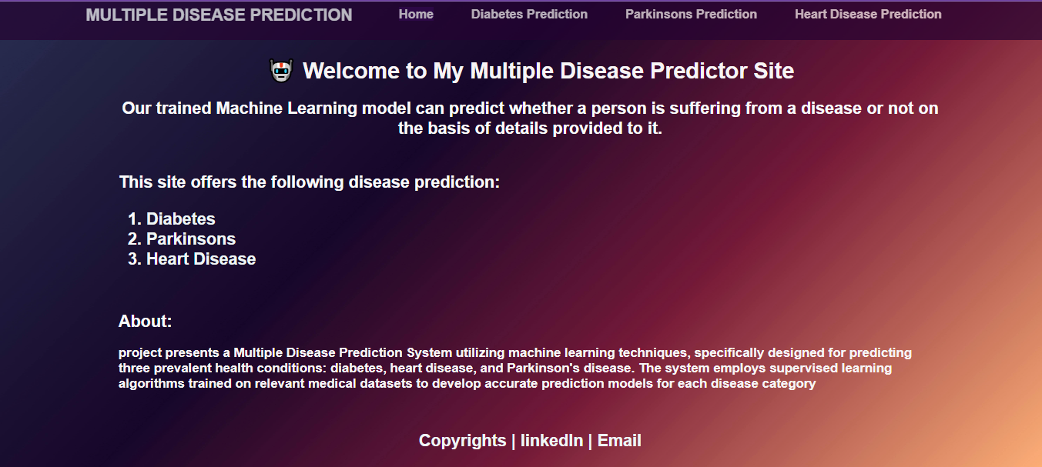

* This contains Home page of the flask web app

**10.2 DIABETES DISEASE PREDICTION**

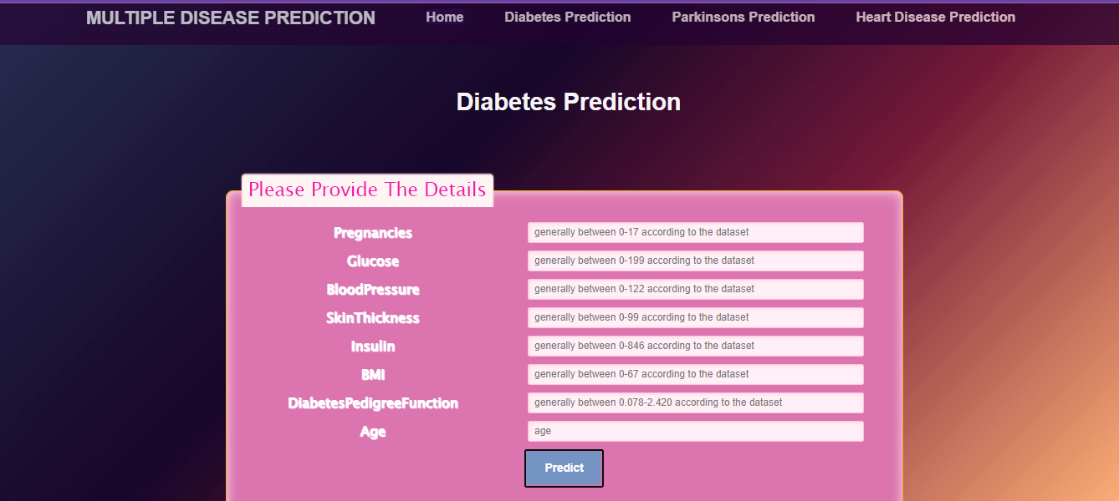

* This is the diabetes prediction page of my flask web app

**10.3 HEART DISEASE PREDICTION**

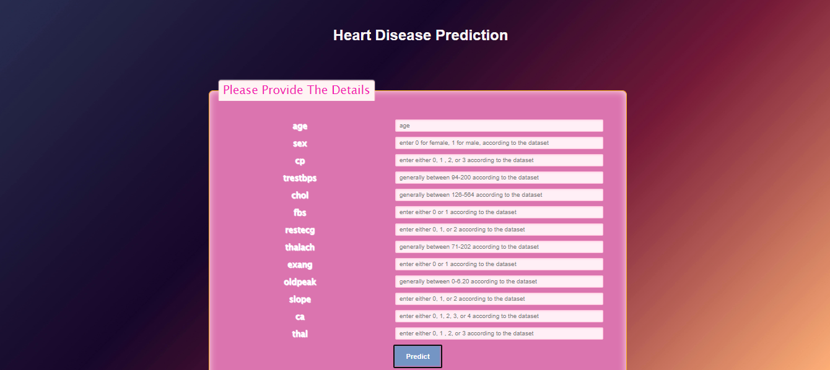

* This page contains Heart disease prediction of the flask web app

**10.4 PARKINSONS DISEASE PREDICTION**

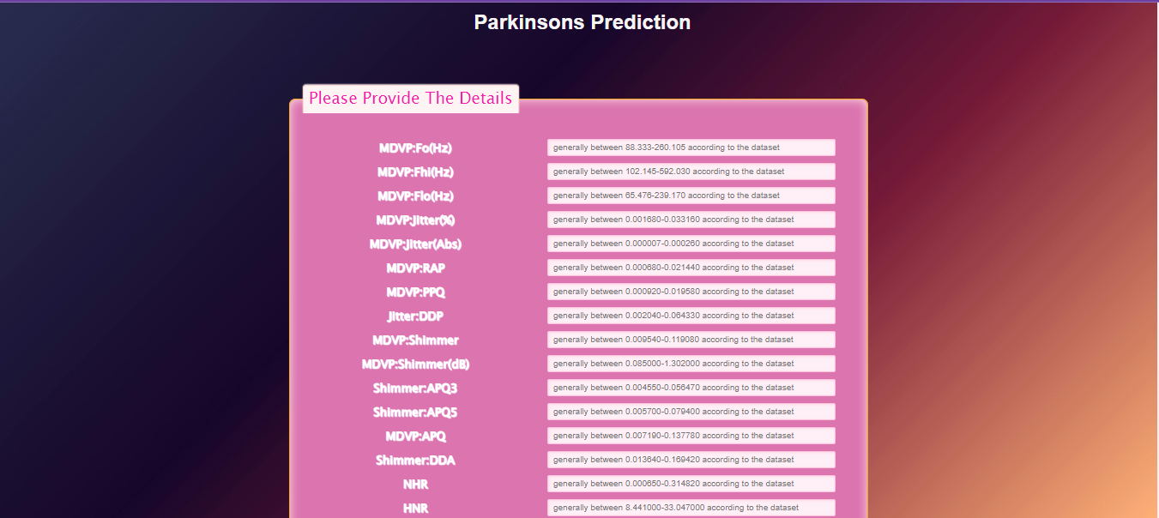

* This page contains parkinson’s prediction of the flask web app

**CONCLUSION**

* 1. **CONCLUSION**
* In conclusion, the Multiple Disease Prediction System project represents more than a technological endeavor; it is a glimpse into the future of healthcare. The accurate predictive models, patient-specific risk assessments, emphasis on interpretability, contributions to preventive healthcare practices, and cross disciplinary collaboration collectively position the project at the forefront of healthcare innovation. As the system transitions from the research and development phase to potential real-world applications, its impact on healthcare practices and patient outcomes is poised to be substantial. The project underscores the transformative potential of technology when aligned with the principles of healthcare ethics, patient centered care, and collaborative innovation. In shaping the future of preventive medicine, the Multiple Disease Prediction System emerges not just as a technological tool but as a beacon guiding the way towards a healthier and more resilient society.

**FUTURE ENHANCEMENTS**

**9. FUTURE ENHANCEMENTS**

* **Integration of Multi-modal Data**: Incorporate diverse data modalities such as electronic health records (EHRs), medical imaging, genomic data, wearable sensor data, and environmental factors into predictive models. Multi-modal data fusion techniques can improve predictive accuracy and provide a more comprehensive understanding of disease risk factors.
* **Deep Learning Architectures**: Explore advanced deep learning architectures such as convolutional neural networks (CNNs), recurrent neural networks (RNNs), and transformer-based models for disease prediction. Deep learning models have the potential to capture complex patterns and relationships in large-scale healthcare data more effectively.
* **Explainable AI (XAI)**: Develop interpretable and explainable machine learning models that provide insights into the factors influencing disease predictions. Explainable AI techniques, such as feature importance analysis, attention mechanisms, and model-agnostic explanations, enhance trust, transparency, and understanding of predictive models by healthcare professionals and end-users.
* **Personalized Medicine**: Move towards personalized disease prediction models that consider individual patient characteristics, including genetic predisposition, lifestyle factors, medical history, and treatment response. Incorporating patient-specific information into predictive models enables tailored risk assessments and personalized preventive strategies, optimizing healthcare outcomes.
* **Continuous Learning and Adaptation**: Implement adaptive machine learning models that can continuously learn from new data and adapt to changing disease patterns, emerging risk factors, and evolving treatment guidelines. Techniques such as online learning, transfer learning, and federated learning enable models to remain up-to-date and relevant over time.
* **Clinical Decision Support Systems**: Integrate predictive models into clinical decision support systems (CDSS) to assist healthcare providers in real-time diagnosis, prognosis, and treatment planning. CDSS can provide actionable insights, evidence-based recommendations, and alerts to support informed clinical decision-making and improve patient care outcomes.
* **Population Health Management**: Enhance population health management capabilities by leveraging predictive analytics for disease surveillance, early detection of outbreaks, and targeted interventions. Predictive models can identify at-risk populations, prioritize resource allocation, and guide public health strategies to mitigate disease burden and improve community health

**REFERENCES AND BIBLIOGRAPHY**

**11. REFERENCES AND BIBLIOGRAPHY**

**11.1BOOK REFERENCES**

* **Flask Web Development: Developing Web Applications with Python" by Miguel Grinberg**:
* This book provides a comprehensive guide to building web applications with Flask, covering topics such as routing, templates, forms, and database integration
* **Python Machine Learning by Sebastian Raschka**
  + This book provides a comprehensive guide to building modern machine learning and deep learning techniques with Python by using the latest cutting-edge open source Python libraries
* **Python Crash Course, 2nd Edition: A Hands-On, Project-Based Introduction to Programming Eric Matthes**
* The book is well presented with good explanations of the code snippets. It works with you, one small step at a time, building more complex code, explaining what's going on all the way.” “Learning Python with Python Crash Course was an extremely positive experience! A great choice if you're new to Python.”

**11.2 WEBSITE REFERENCES**

**Official Flask Documentation :** (https://flask.palletsprojects.com/en/3.0.x/)

**Python Documentation :**  (https://docs.python.org/3/library/index.html)

**Flask GitHub Repository :**  ( https://github.com/topics/flask)

**Machine learning :**  (<https://www.geeksforgeeks.org/machine-learning>-algorithms/)